Company Overview: Subsea 7 is an offshore energy services company that participates in the full lifecycle including design and engineering, installation and maintenance, and decommissioning. The company has two segments 1) subsea and conventional and 2) Offshore Renewables. This industry has high barriers to entry and their main competitors are limited and control a large share of the market. In the subsea endmarket, only two major competitors Saipem and TechnipFMC are major players which is a drastic change from a decade ago when Subsea had ~10 competitors. The increased consolidation, lack of investment, and abandonment of large tranches of private capital/small operators had led to increased rationality. Furthermore, there are no signs of new entrants and significant new capacity additions in the context of new vehicles will take in excess of 3yrs given the shipyard backlogs. In recent years, the company has fully consolidated a related business (Seaway) that specializes in offshore wind. The capabilities in renewables are now profitable, with a growing backlog of contracts. While the renewables segment is still small with ~20% of the total group EBITDA generated, further margin improvement and backlog growth could create material upside to this segment in the coming decade.
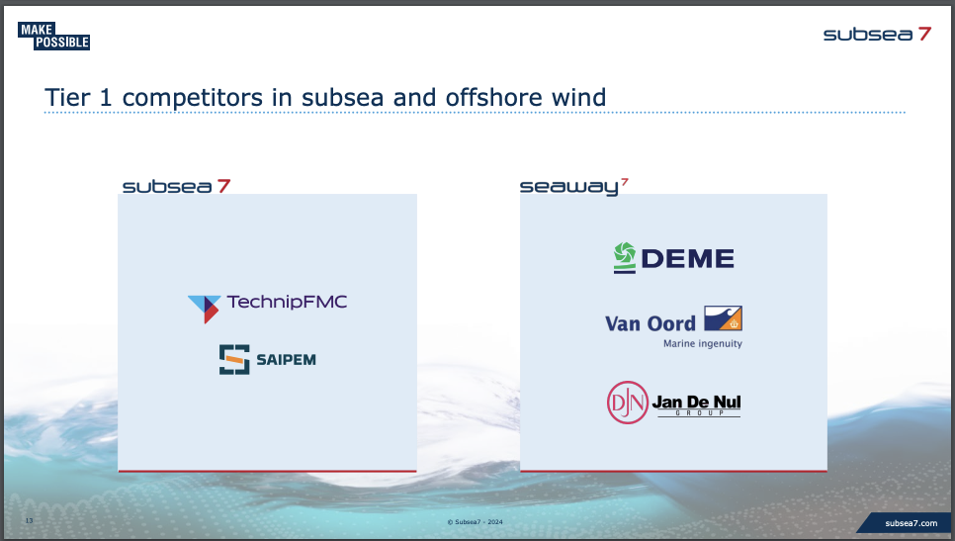
Thesis: The company remains in the early stages of an FCF inflection point with CAPEX trimming down to support FCFF % conversion ~50%, EBITDA growth of ~10% y/y as growing backlog is converted to revenues, and margin improvement of 400bps because recent work was bid for in a tighter market.

Subsea trades at ~6.0x 2024 EBITDA and 6% 2024 FCFF yield. However, the valuation looks much more compelling on 2025 numbers (guided and estimated). Subsea trades at ~5x EV/’25 EBITDA and close to 10% ‘25 FCFF yield. This undemanding valuation supports the more thematic/cycle thesis.

- Margin Inflection: The reason is that Subsea generates a majority of its business from fixed-priced contracts. Fixed priced contracts, for a good operator, should on average generate better profitability (% margin) relative to a cost-plus operator. That said, execution risks and cost over-run risks are borne by the contractor. In the case of Subsea, the company clearly suffered from cost inflation over the past few years which has depressed margins on the order of 200-400bps. The headwinds are now flattening and turning into tailwinds for Subsea which is driving significant margin improvement in the next few years. The company is pointing to a margin progression of 16%-> 19% -> 20%+ for 2024,2025, and 2026 respectively. We view this as credible as the company has ~2yrs of backlog and embedded backlog margin visibility coinciding with a general view of global inflation stabilizing at this point.
- Favorable Market Structure: As mentioned previously, the space that Subsea competes in has drastically consolidated over the past decade. The fewer operators heading into the next offshore cycle should allow both better profitability than past cycles and increased length before new capacity is added. Furthermore, main industry competitors (Saipem/TechnipFMC) are largely echoing Subsea’s views on CAPEX which creates further comfort on not much incremental supply investments in the next few years
- Compelling Valuation: As a whole, valuation is compelling. We see company guidance as light for 2024 and likely 2025 as well. That said, the market seems to understand this given that sell-side consensus is modestly higher than guidance. While we do not take much of a differentiated view on earnings trajectory, we broadly see the set-up and share-price as broadly attractive to own. We take a SOTP valuation approach wherein we value the Deepsea conventional segment separately from the Renewables segment. As a whole, valuations for each segment are not drastically different on fundamentals. Renewables has a lower current margin but with higher growth in the next few years that mitigates the lower margin. The segment overall has higher variance of outcomes, which is to be expected as it is a newer focus area for the company. We believe that this business is worth ~5x EV/EBITDA and approximately $1bn in TEV. The deepsea segment generates $1.1bn of EBITDA and can comfortably be valued at ~5.0x. This is underpinned by OFS comps and historical peak-to-trough forward EBITDA range that is comfortably range bound between 4-7x. Investing in Subsea provides an asymmetric skew with minimal downside and a chance for significant upside. The upside valuation is 1) dependent on progression in the quality of the renewables business (multiple of as much as 7x) and 2) The multiple on Deepsea which needs investors next year to see conditions as good as they are currently as it relates to upswing duration, backlog growth etc.
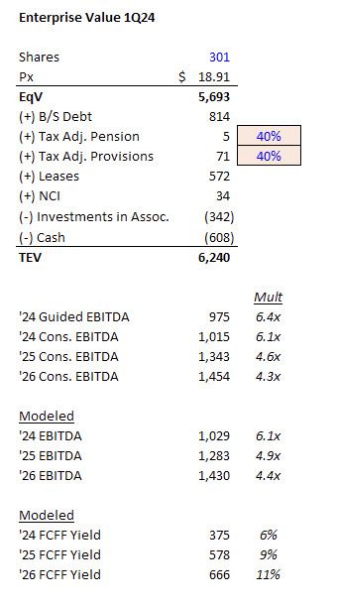
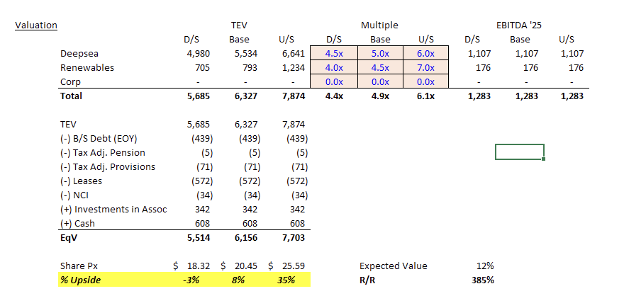

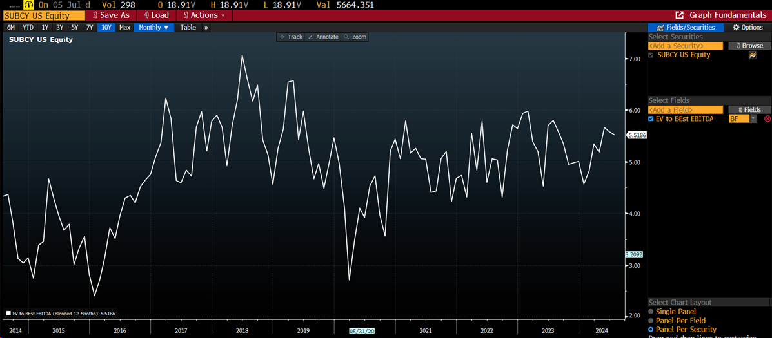

- Attractive Multi-Year IRR: The IRR on this as a long term investment is quite attractive. Assuming somewhat an isometric multiple, the cash generation in 2024-2026 should net ~20% IRR which we see as very attractive for a public equity investment
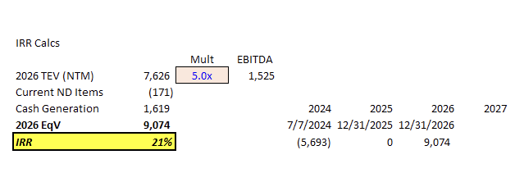

Catalysts: The company should be in a good position to increase the guidance for 2024 likely in 2Q results. This should be viewed as positive. In addition, we also see many more quarters of backlog addition as the offshore activity continues to pick up. This could lead to everyone’s estimates for 2025 revenues being materially lower than the backlog implied revenue

